Java ResultSetMetaData Interface->

*The metadata means data about data i.e. we can get further information from the data.

*If you have to get metadata of a table like total number of column, column name, column type etc. , ResultSetMetaData interface is useful because it provides methods to get metadata from the ResultSet object.

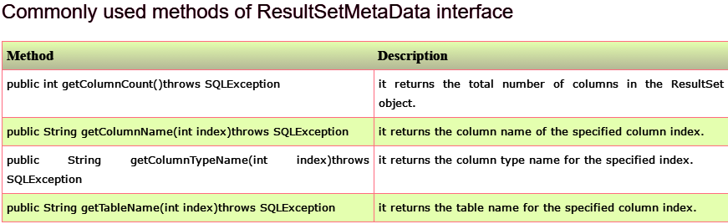

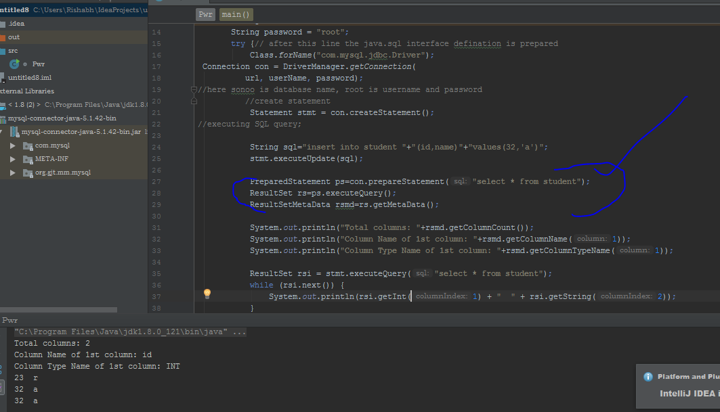

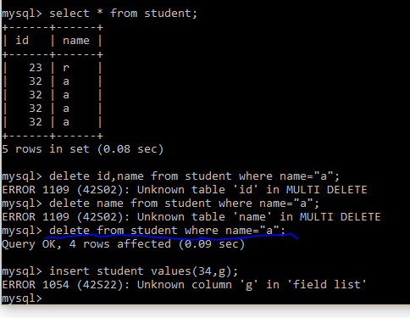

# Java DatabaseMetaData interface->

# * DatabaseMetaData interface provides methods to get meta data of a database.

# * such as database product name, database product version, driver name, name of total number of tables, name of total number of views etc.

